Our Ref: _______________ Your Ref: ________________________ Date: __________________

Baptist Church

Baale Yaku Site Area, P. O. Box 644,

Ogbomoso, Oyo State. Tel. 07052425407

Email: [newsprinbaptistchurch@gmail.com](mailto:newsprinbaptistchurch@gmail.com)

Website: newspringbc.comze.com

NEW SPRING

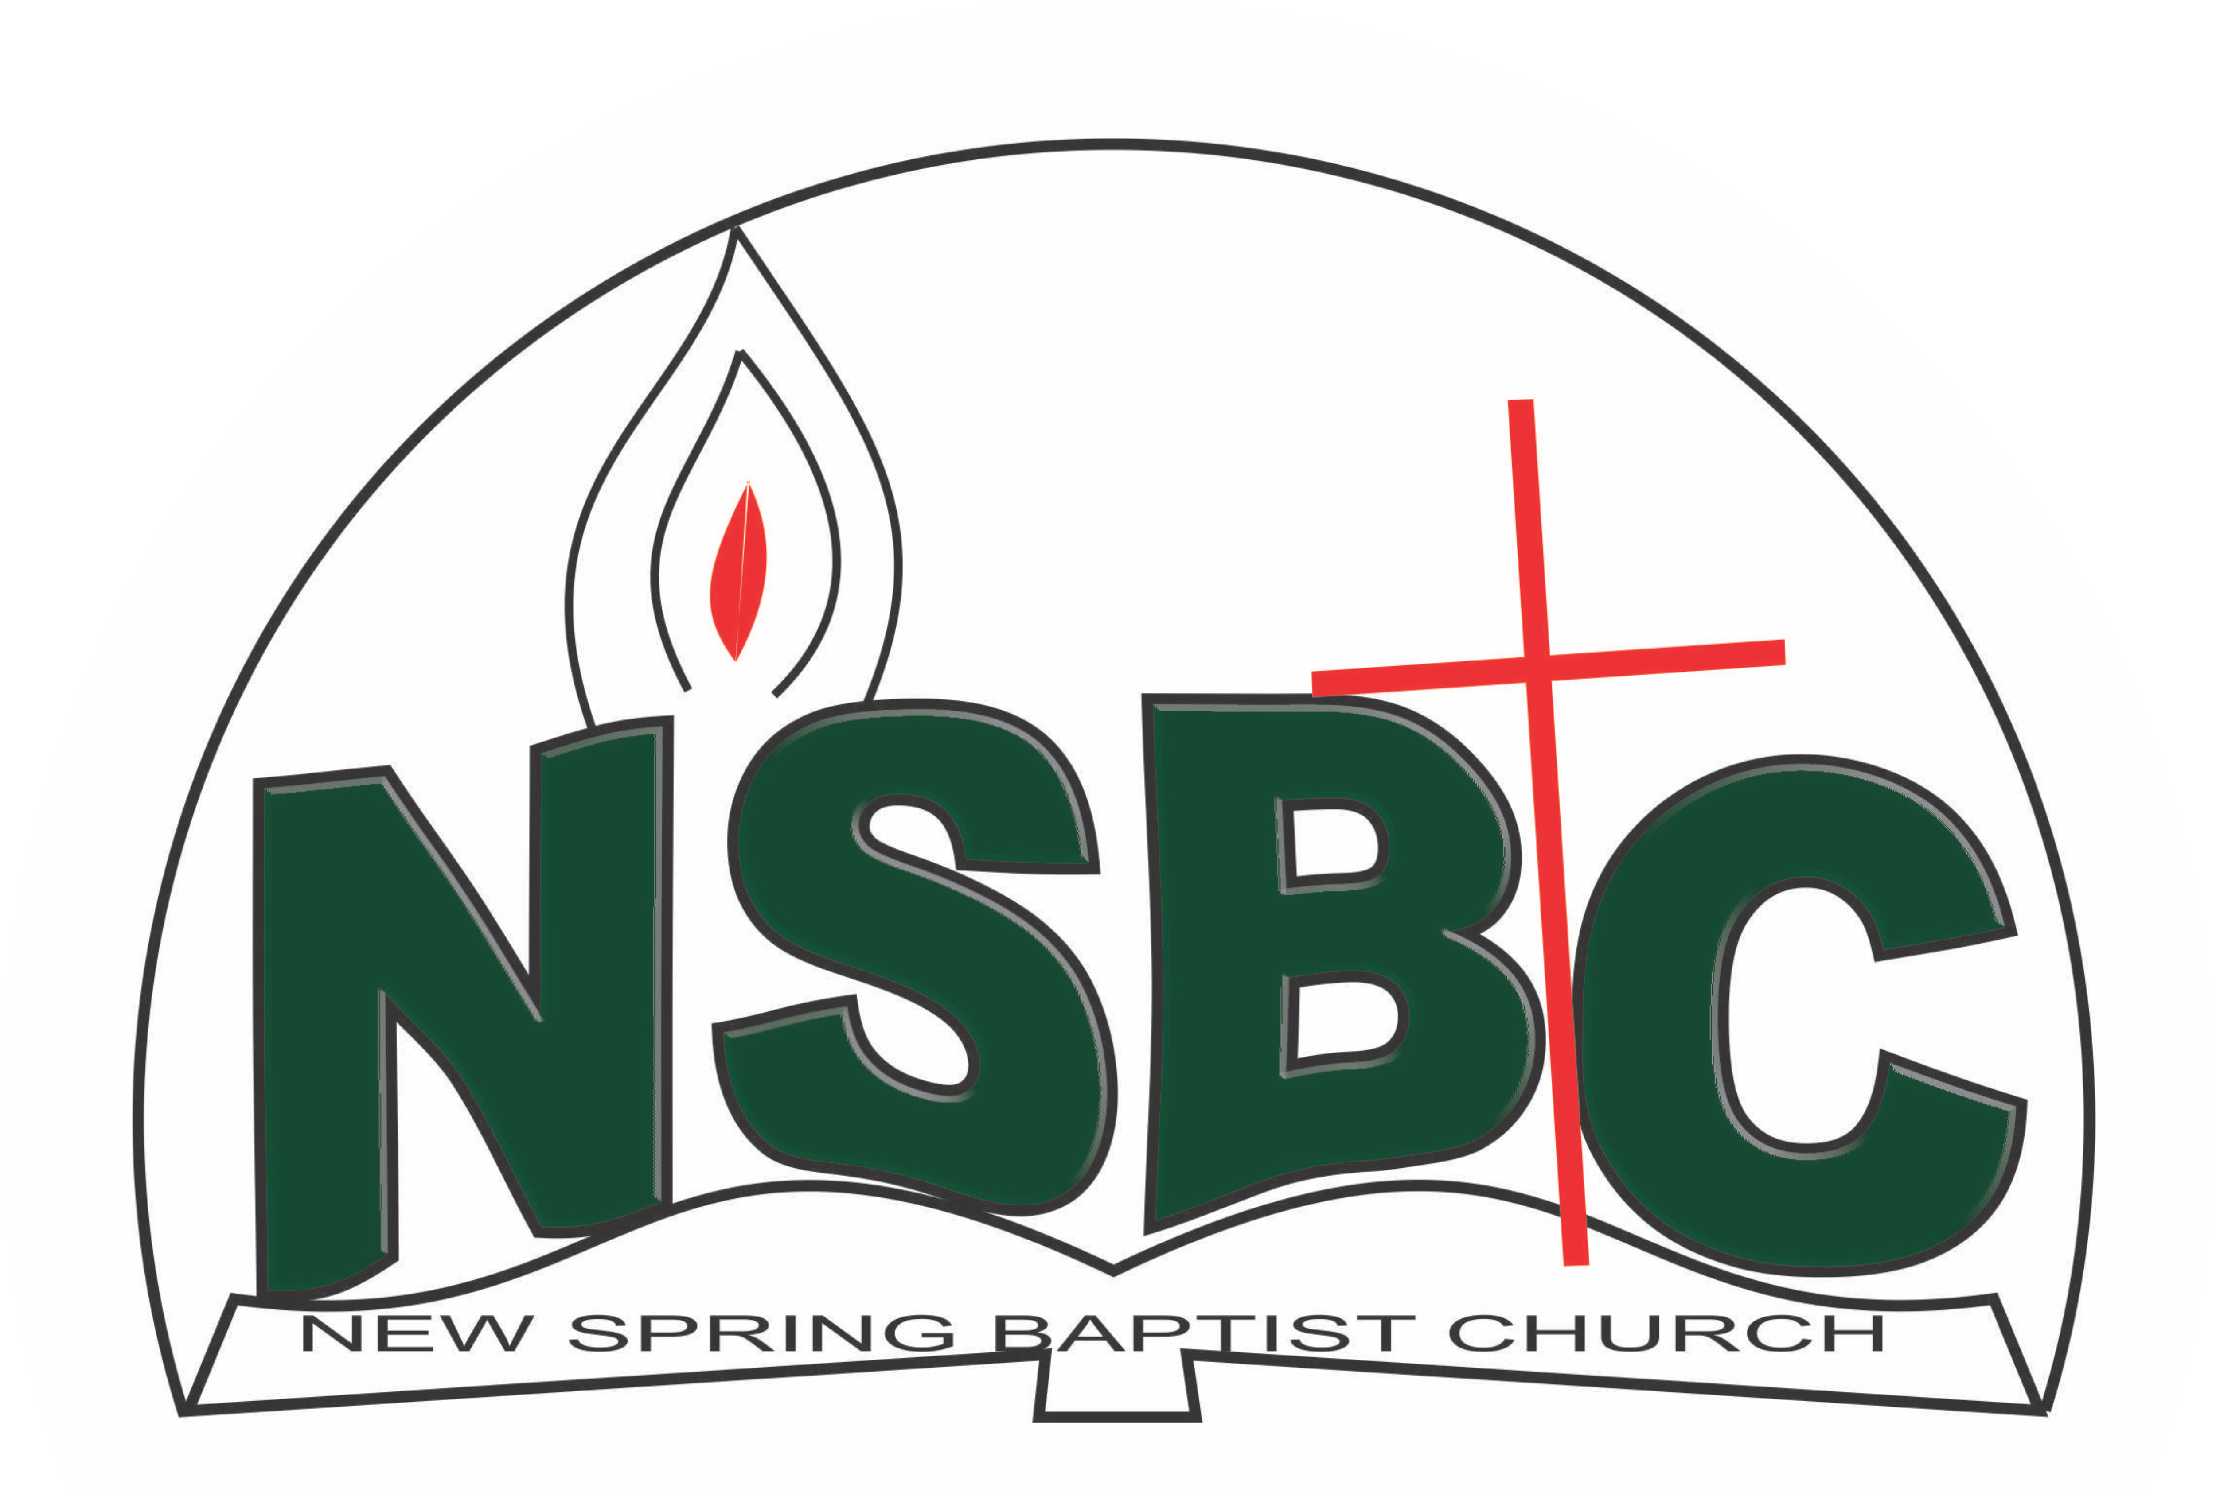

December 27, 2021

Dear Mr. Yinka Akanbi,

Nomination to Serve as a Worker in the Church in 2022

Calvary greetings in the precious name of our Lord and Saviour Jesus Christ. It is our pleasure to inform you that, at the Church-in-Conference held onDecember 19, 2021; the Church ratified your nomination to serve in the following areas between January 1 and December 31,2022.

1. Coordinator, Children’s Department under the Chairmanship of Pst. Paul Adeoye
2. Member, Church Property Committee under theChairmanship of Mr. Rotimi Adeniyi
3. Member, Drama Committee under the chairmanship of Mr. Bayo Babarinde
4. Member, Beatification and Decoration Committee under the chairmanship of Mr. Akin Ogunlowo

Please refer to the table below for the key functions of each of these roles. Details can be found in the Church constitution. You are strongly encouraged to become familiar with the tasks as stated in the document. There will be an orientation of the Church workers on January 15, 2022 at 8:30 a.m. on the church premises. Please ensure you participate in this training.

“Now it is required that those who have been given a trust must prove faithful. I Corinthians 4:2”. May God find you faithful in the task He has assigned to you.

| Domain | Key function of Office, Department or Committee |
| --- | --- |
| Coordinator, Children’s Department | Responsible for organizing activities that contribute to the spiritual nurture of children from birth to 12 years |
| Church property | Responsible for managing all Church fixed and non-fixed properties |
| Drama | To coordinate both internal and external efforts in evangelism through drama |
| Member, Beatification and Decoration Committee | The committee is responsible for the ornamentation of the Church building and premises, responsible for securing, arranging and disposing of decoration materials for Church services and shall also arrange to decorate the Church during all other special services. |

Thank you for accepting to serve in this Church.

Yours in His service

Olusayo Okediji Blessed Agboola

Church Secretary Chairman, Nominating Committee